**DECIMAL TO BINARY CONVERSION**

**EXP NO: 25**

**AIM:**To write a C program to implement decimal to binary conversion.

**ALGORITHM:**

1) Check if your number is odd or even.

2) If it's even, write 0 (proceeding backwards, adding binary digits to the left of the result).

3)   Otherwise, if it's odd, write 1 (in the same way).

4)   Divide your number by 2 (dropping any fraction) and go back to step 1. Repeat until your original number is 0.

**PROGRAM:**

#include<stdio.h>     
#include<stdlib.h>   
int main()  
{   
int  
a[10] ,n , I ;     
printf ("Enter the number to convert: ");     
scan f("%d", &n);     
for(i=0;n>0;i++)     
{     
a[i]=n%2;     
n=n/2;     
}     
printf("\n Binary of Given Number is=");     
for(i=i-1;i>=0;i--)     
{     
printf("%d", a[i]);     
}     
return 0;   
}  
  
  
 

**INPUT:**

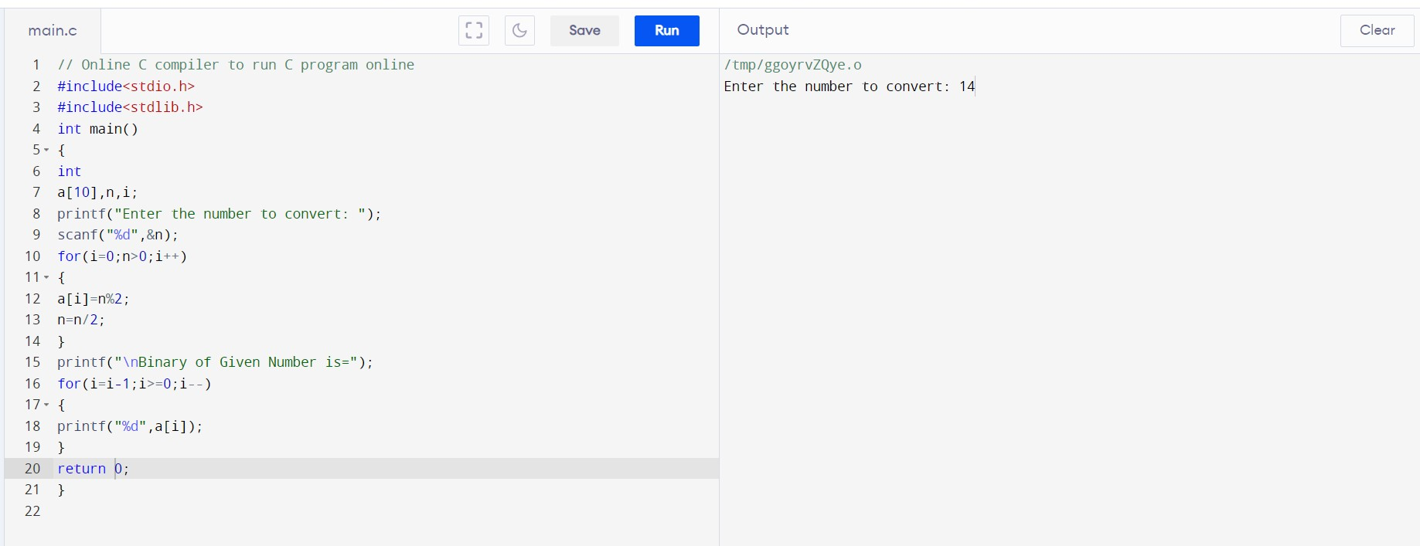  
  
  
  
**OUTPUT:**

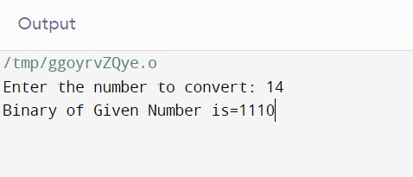  
  
  
**RESULT:**Thus the program was executed successfully using Dev C++.